**AI VOICE CLONE**

**PROJECT SYNOPSIS**

OF MINOR PROJECT

**BACHELOR OF TECHNOLOGY**

Computer Science and Engineering

SUBMITTED BY

SANDEEP KAUR (1806007)

GURSIMAR KAUR (1820036)

February 2020

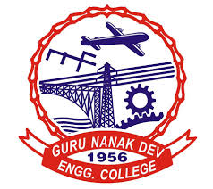

**GURU NANAK DEV ENGINEERING COLLEGE,**

**LUDHIANA.**